**Meigs Graphs**

**PPAC Graphs**

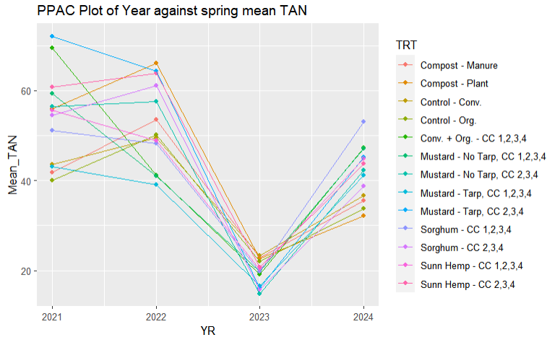

**SWPAC Graphs**



